**Backend:**

**Customer accounts**

Creating new customers:

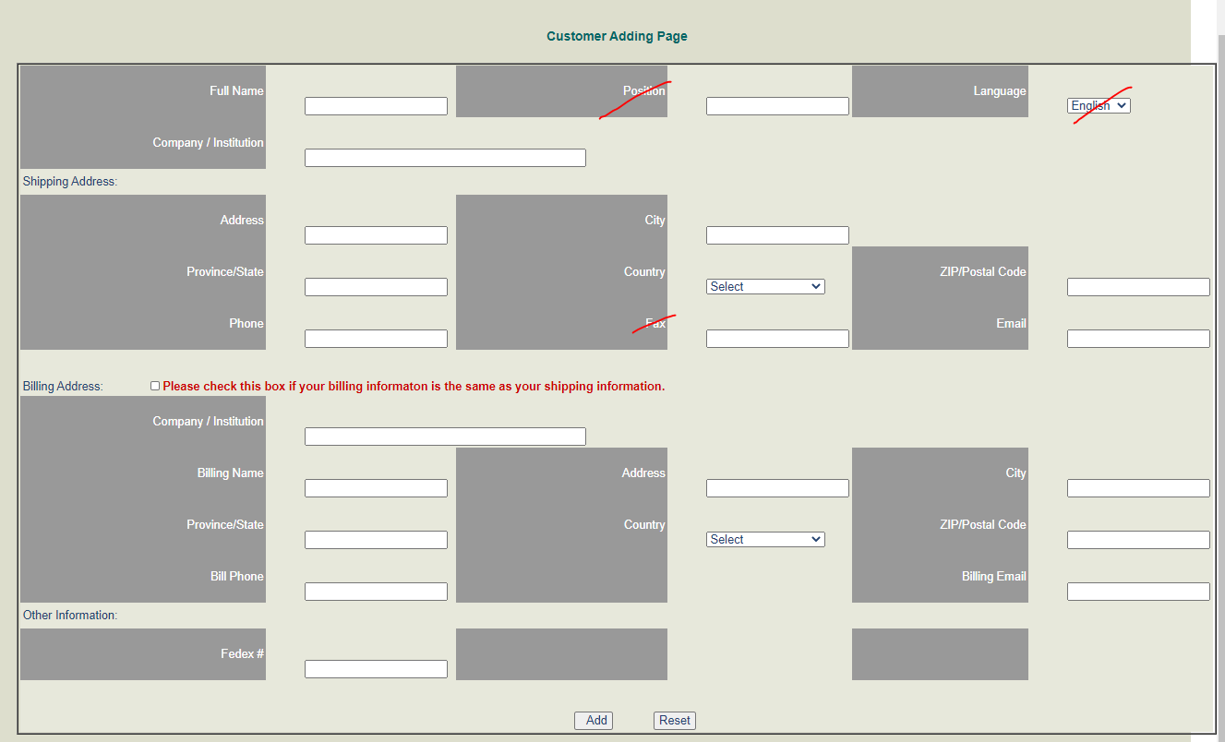

* Ability to add new customer’s so that they have an account with us. Account needs to contain the following fields:

A) Shipping:

1. First name
2. Last name
3. Company / Institution
4. Shipping address (street address, city, province/state, country, postal code)
5. Phone number
6. Shipping email
7. VAT number
8. FedEx account #
9. Broker name
10. Broker address
11. Broker email
12. Broker phone number

B) Billing:

1. First name
2. Last name
3. Company / Institution
4. Billing address (street address, city, province/state, country, postal code)
5. Phone number
6. Billing email

* If the customer’s billing and shipping information is the same, be able to enter in the customer’s shipping details, and click a box to auto-populate the billing fields.
* Two notes field so that we can enter in notes specific to this customer, without having to type in html code to format (bold, underline, highlight, type in different colors etc.).

1. Note 1 is for important notes so that we can input details such as “ USD$600 from order xxxxx available, credit used up in_____”.
2. Note 2 is for all other notes

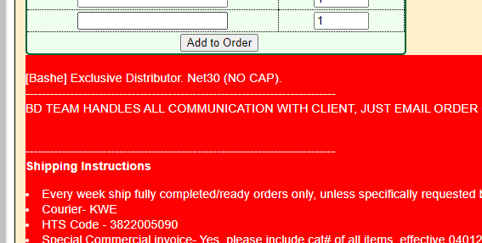

Existing customer accounts:

* Be able to go to a customer’s account and see:

1. Past orders placed (with the following information)

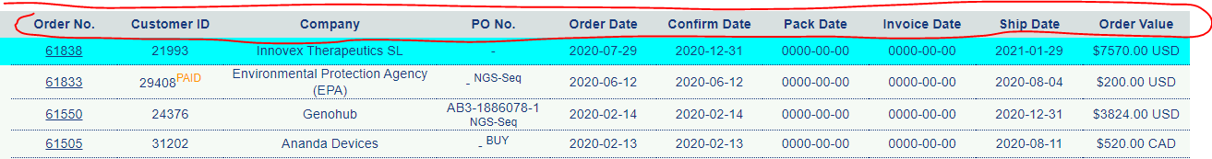

1. A list of quotes created for this customer and see:



* Search for a customer’s account using customer’s full email, email domain (e.g. @cosmobio.co.jp), institution/company name, shipping name, Customer ID

**Quotes:**

* Generate new quotes

1. Search for a customer’s account using customer’s full email, email domain (e.g. @cosmobio.co.jp), institution/company name, shipping name, Customer ID
2. Select customer’s account and click ‘generate quote’
3. Would need to be able to see account notes at this point (i.e. this function is not available on Magento, but is available in the old backend)

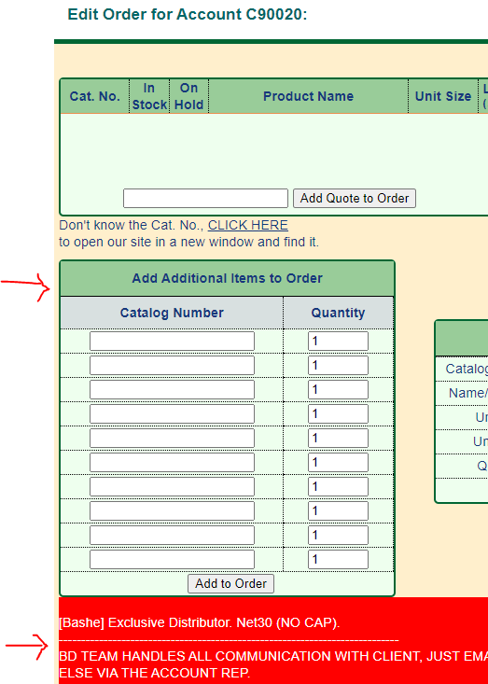

1. Enter in multiple catalog numbers (using full 12 digit catalog numbers instead of having to select the last 5 digits each time) and quantities. Currently Magento asks you to configure each time:

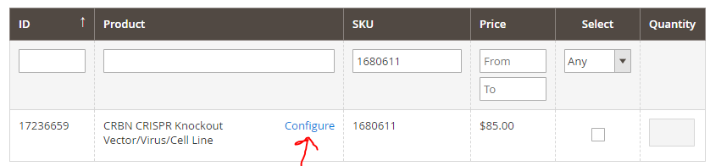

The old backend allows full catalog numbers to be entered:

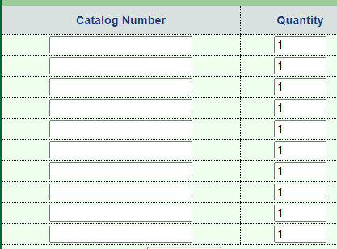

1. Click ‘add to quote’, and the following fields should show up:

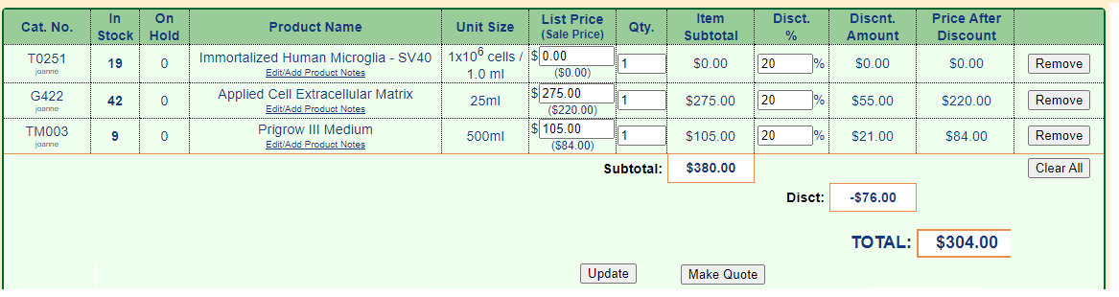

* Be able to enter in items in the order in which it is entered, and at the same time. Old backend is good and allows this to happen:

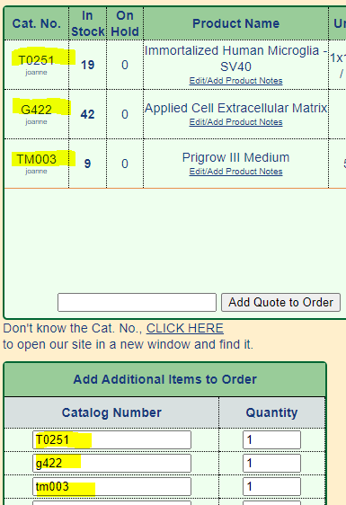

Magento backend:

Would need to search for each one individually:

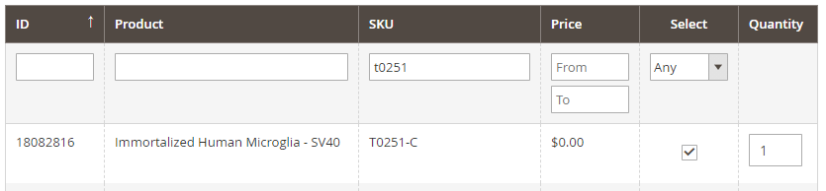

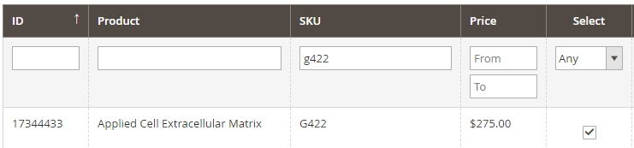

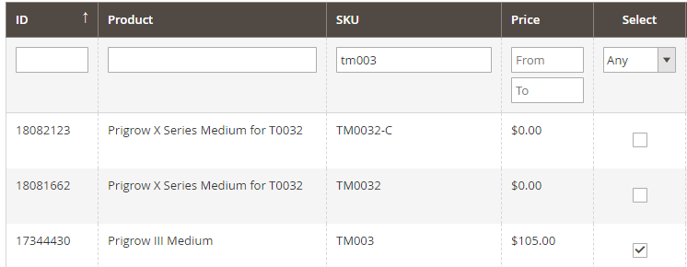

And the order in which the items are listed is the opposite:

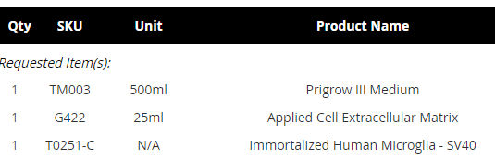

* Be able indicate which product is a “required item” and which is a “recommended item”
* Be able to adjust the “list price” and “discount %” column and have the “price after discount” column automatically calculate
* Currently if the list price is adjusted or entered in Magento 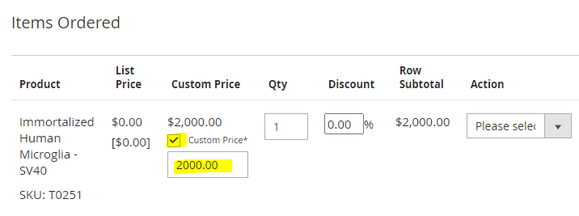

The ‘list price’ column is not updated

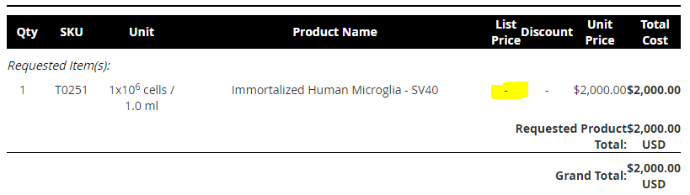

* Have distributor and OEM discount percentages automatically populate
* Geo-price the list price 1.15X automatically if the customer’s ship-to country is Canada
* Geo-price the list price 1.5X automatically if the customer’s ship-to country is outside of Canada or the US
* Be able to add new catalog numbers, e.g. C098-1, Custom-1, Peptide-1
* Be able to enter in custom items where we can set the product name, unit size, list price, quantity, discount level
* Be able to enter in notes under each item if desired, without having to use html coding to format
* 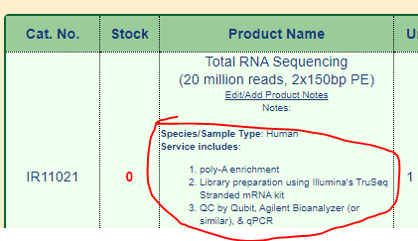
* Show accurate stock quantity beside each item

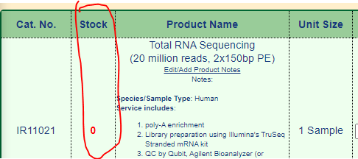

* If item is in stock, indicate the quantity
* If item is out of stock, indicate the lead time (e.g. 2-3 weeks)
* Be able to set the quote expiration date
* Be able to enter in “aim”, “deliverables”, “lead time”, “external notes”, “internal notes” and format without having to type in html codes

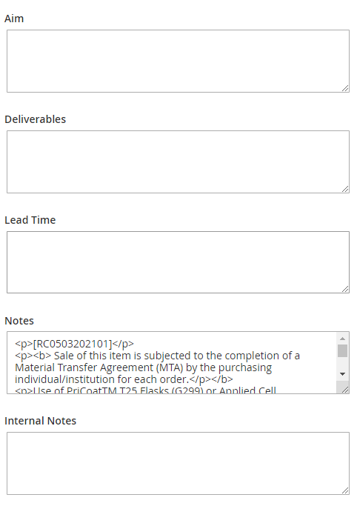

* Be able to set the currency (i.e. USD or CAD)
* Click ‘Submit quote’
* Set the quote expiration date
* 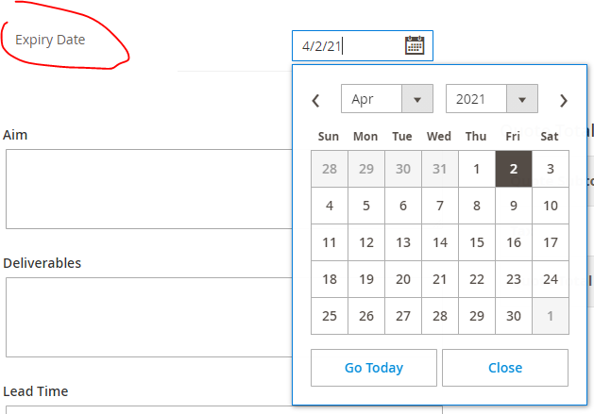
* Click “print quote” to generate a PDF, e.g. abm quote Q1004109
* Do not show the discount column on the PDF if 0% discount is applied
* Show the discount on the PDF if a discount is applied and indicate “you saved $____ today!” and the bottom of the quote
* Show the currency on the quote
* Be able to search for quotes using:

1. quote number
2. Catalog number
3. Customer’s email
4. Customer’s name
5. Institution/company name

And see:



* If a quote has turned into an order already, display order number and link to the corresponding order
* After a quote has been generated, have the ability to pull up quotes and make the following changes:
* add/remove items
* select if an item is a recommended or required item
* adjust currency
* adjust list price
* adjust discount %
* adjust quantity
* adjust any notes section
* adjust quote expiration date

**Order:**

* Be able to search for orders using order number, customer’s shipping email, institution/company name, PO numbers, customer’s name, Product catalog numbers, Product name
* Be able to place an order from an existing quote
* If an order is placed from a quote, show the quote number and link to that quote
* Clearly indicate the status of an order, e.g. paid, complete, on hold, pending payment, pending MTA, pending customer’s reply, pending tax ID
* Be able to print orders into PDF files
* If an ordered has been invoiced, indicate the invoice number, invoice date and include a link to that invoice
* Clearly show if an order has been paid or not
* Show the currently on the order
* Be able to adjust the contact details (e.g. customer’s name, shipping address, billing address, phone number, email, tax ID, FedEx account #)
* Be able to add/remove items
* Be able to edit the list price, quantity, discount %, notes section
* Be able to see if an order has been paid, partially paid, or unpaid but do not show two different pricing (e.g. 000006315)

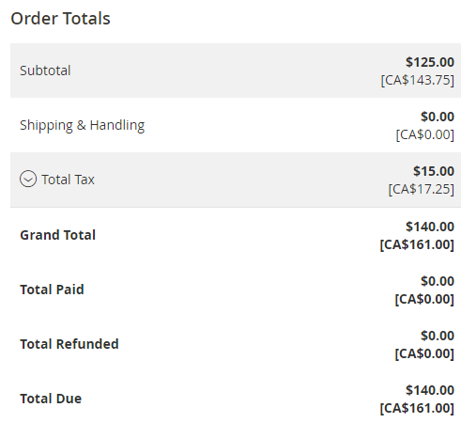

* If an order is placed from a quote, display quote number and link to the corresponding quote
* Be able to enter in and edit notes without having to use html code format.

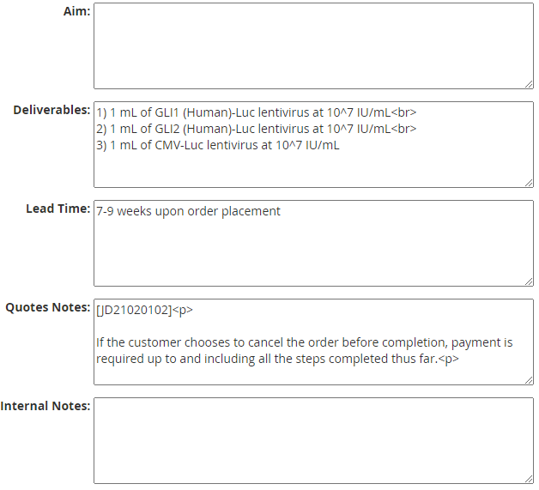

**Sales history:**

* Be able to search for orders using catalog number, order number, customer’s shipping email, institution/company name, PO numbers, time frame during which order is placed (e.g. Nov 1st 2018 - Jan 15th 2021). Old system is currently too slow, Magento is faster.

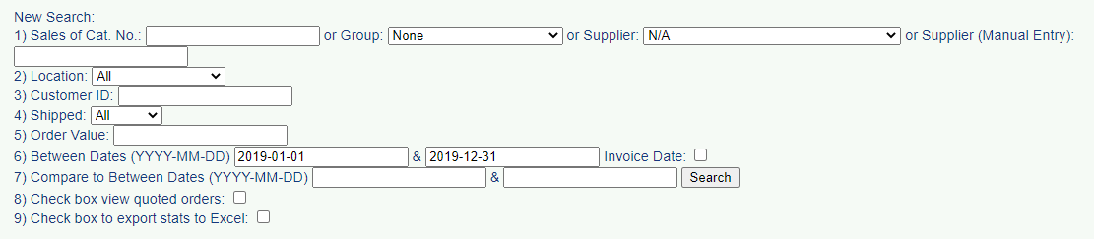

* Be able to search using specific catalg numbers and see how many of that particular item has been ordered
* Be able to search using specific catalg numbers and see how many of that particular item has been shipped

**CSL:**

* Link CSL to orders, e.g. when I open order 61838, there is a link to the CSL. This feature is present in old backend, but absent in Magento backend

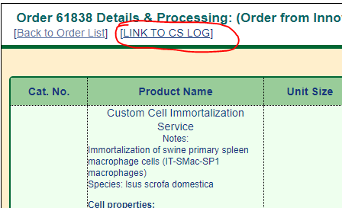

**Inventory:**

* Be able to search using catalog numbers and see the amount of inventory, name of product, unit size, price, supplier, location
* If something is out of stock, show the lead time
* Search function needs to be fast as this is used every day
* Be able to add and see notes for particular items, e.g. 3950/7950 Special MTA required, i.e. need a notes section

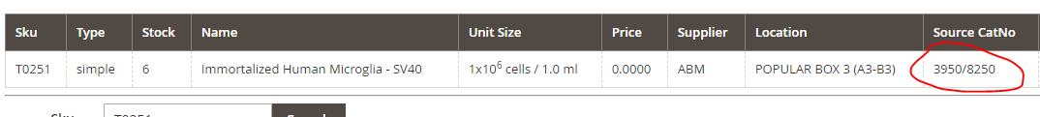

* Show shipping condition, e.g. dry ice, ice pack, room temperature
* Ability to search using catalog numbers regardless of if capitalized or lower case is used. E.g. Currently search does not work if alphabets are not capitalized

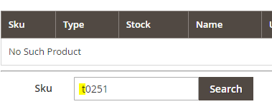

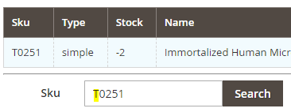

* Be able to search for inventory status using full catalog numbers instead of having to select for “1”, “02”, “95”

E.g. If searching for 109170810295, no inventory shows up:

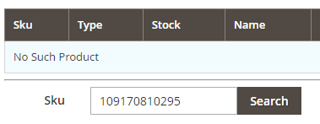

If searching for “1091708”, something shows up but would need to select for “species”, “features”, and “vector/virus/cell”

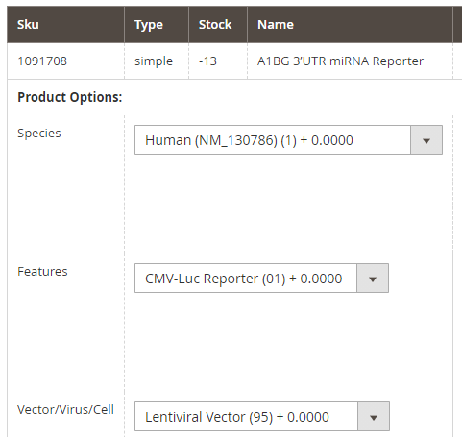

I would like to be able to enter in the full catalog number without having to make further “species”, “features”, and “vector/virus/cell” selections.

**Search function:**

* Search function not efficient currently. Have to remove previous search terms before entering the second search term. I.e. would need to remove any active filters before entering a second search term in the search bar.

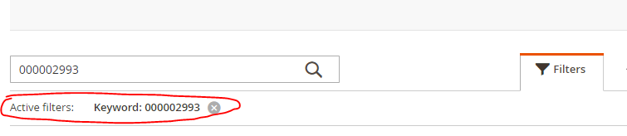

* Old backend has a side bar with different search functions which is more efficient. With Magento, we currently need to select sales🡪orders, or sales🡪 quotations before we can access the search bar.

Old backend:

